Capstone Final Project

Patrick Mbia

# Neighborhood Similarities

# Problem Description

A customer leaving in Roncesvalles Village, Toronto (Canada), has just found a new job that would require location to New York.  
Her request is to find a suitable neighbourhood in New York that bear the same similarity as her current one,  
so that she does not feel out the place once she moved in. Her current neighbourhood, Roncesvalles Village, is predominantly residential,  
with a commercial strip the full length of Roncesvalles, composed predominantly of small businesses, churches and institutions.  
Culturally, the area is known as the centre of the Polish community in Toronto with prominent Polish institutions, businesses and St Casimir's Catholic Church located on Roncesvalles Avenue. Roncesvalles Village's geolocation coordinates are: Latitude 43.646231 and Longitude: -79.449048.

# Data Source

The source of data used in this project will originate from the Foursquare location data (<https://foursquare.com/>).  
Foursquare is a local search-and-discovery that provides personalized recommendations of places to go near a user's current location based on users' previous browsing history and check-in history. The Foursquare will allow us the find places that have similar categories in New york as the ones in Roncesvalles Village.

# Approach

The task will be to find the similarities between Roncesvalles and some of New York neighbourhoods.

Data clustering will be used to categorize the New York venues base on common venue categories.

A list of potential similar neighborhoodlike to Roncesvalles will then be predicted.

# Data Analysis

Roncesvalles top venues:

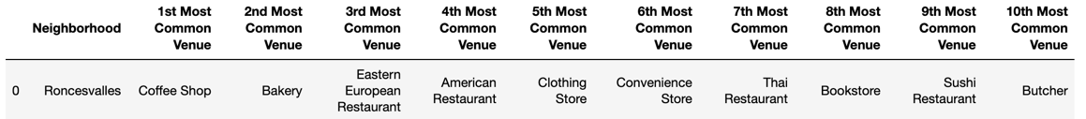

New York top venues:

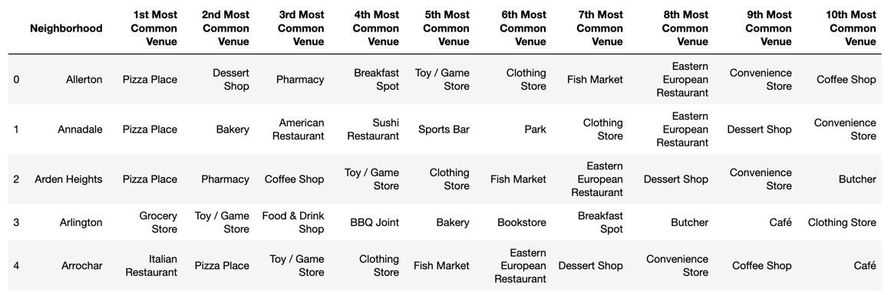

New York Neighbourhoods clustering:

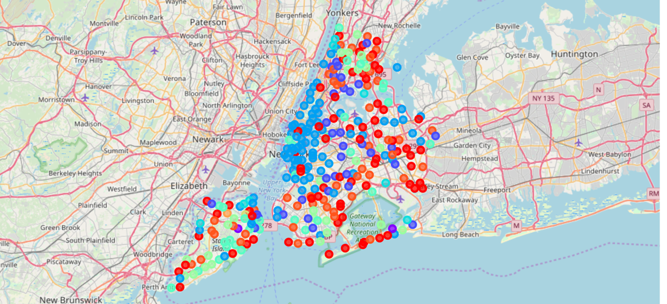

# Results

Neighbourhoods similar to Roncesvalles:

